**WERC Global 25 Speaker Marketing Toolkit**

As a speaker at WERC Global 25, you play a pivotal role in shaping conversations that will influence the future of talent mobility. This toolkit is here to help you promote your session and elevate the value of the event across your network. Inside, you’ll find key messages, social media templates, graphics, a promotional email, QR code, and guidelines to submit a short video. Let’s make your session one to remember.

## Event Overview

* WERC Global 25 takes place **28–31 October 2025** at the **Salt Palace Convention Center** in **Salt Lake City, Utah**.
* As the premier global event for talent mobility professionals, WERC Global 25 brings together corporate, government, and service provider leaders for four days of actionable education, future-focused conversations, and powerful connections.

## Sample Social Media Posts

Promote WERC Global 25 by posting on your social media channels. Feel free to customize the posts and use your “voice.” Consider having fun with your social posts by including emojis and hashtags!

Don’t forget to follow WERC on social media and tag us.

* [Facebook](https://www.facebook.com/WorldwideERC)
* [LinkedIn](https://www.linkedin.com/company/66468?trk=tyah&trkInfo=clickedVertical%3Acompany%2CclickedEntityId%3A66468%2Cidx%3A3-1-6%2CtarId%3A1458075737848%2Ctas%3Aworldwide%20ERC)
* [Instagram](https://www.instagram.com/worldwideerc/)

**Social media tips:**

* Posts on your social media channels should generally be kept as short as possible and **include** hyperlinks and hashtags.
* Consider posting at high-trafficked times during the week to maximize your exposure. The optimal time to post is between 13:00 and 15:00 in your primary audience’s time zone, Monday through Thursday.

Below, we have provided some template examples, but you can and should make it your own. Tell the audience what they’ll learn or why you’re excited to be at WERC Global specifically.

**Standard**

1. I'm speaking at #WERCGlobal25! Don’t miss my session on **[topic]**, taking place **[date of your session**] October in Salt Lake City. Register now: [www.talenteverywhere.org/Global25](http://www.talenteverywhere.org/Global25)
2. Join me in Salt Lake City for #WERCGlobal25, where I’ll explore **[topic]** and connect with global mobility pros from around the world. [www.talenteverywhere.org/Global25](http://www.talenteverywhere.org/Global25)
3. WERC Global 25 is where talent mobility meets innovation and I’m proud to be part of the speaker lineup. Don’t miss it: [www.talenteverywhere.org/Global25](http://www.talenteverywhere.org/Global25)

## Email Template

**Subject:** Join Me at WERC Global 25

Hi [Name],

I’m excited to invite you to [**WERC Global 25**](https://www.talenteverywhere.org/Events/WERC-Global), taking place 28–31 October 2025 in Salt Lake City, Utah at the Salt Palace Convention Center.

As a speaker, I’ll be presenting **[your session topic]** on **[date/time]**. This session is packed with insights that can help you stay ahead in an evolving talent mobility landscape. **[Add some specifics about your session and what attendees can expect]**.

**Why attend?**

* Hear from global thought leaders on immigration, AI, remote work, sustainability, tax, and more.
* Network with peers and partners across sectors and regions.
* Discover tools and ideas to drive real growth in your role and organization.

👉 [**Register now**](https://www.talenteverywhere.org/Events/WERC-Global/Registration) to be part of the conversation. I’d love to see you there!

Best,

**[Your Name]**

**[Your Title/Organization]**

**[Contact Information]**

](https://www.talenteverywhere.org/Events/WERC-Global/Registration)

**Note:** Make sure to hyperlink this graphic with the registration link: [www.talenteverywhere.org/Global25](http://www.talenteverywhere.org/Global25).

## Boilerplate

**28–31 October 2025 | Salt Palace Convention Center | Salt Lake City, Utah**

[WERC Global 25](https://www.talenteverywhere.org/Events/WERC-Global) is the premier event for the talent mobility industry, uniting professionals from across the globe to share strategies, form connections, and spark innovation. This year marks WERC’s 60th anniversary, and our program reflects that milestone with elevated content, immersive experiences, and global reach.

Expect cutting-edge sessions, interactive sessions, a sold-out expo hall, and inspiring moments like the opening keynote from Paralympian and changemaker **Amy Purdy**. Whether you're a corporate mobility leader or a service provider, this is your space to learn, grow, and lead.

**Register:** [www.talenteverywhere.org/Global25](http://www.talenteverywhere.org/Global25)

## QR Code

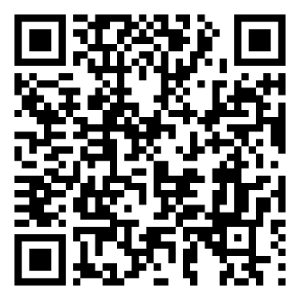To make it easy for your network to register, include the following QR code in your communications:

*Scan to Register*

## Social Media Graphics

Add these to your website, social media posts, and corporate communications promoting the event. To download the graphics, hover on the select graphic, **right-click** and select **“save as picture**.”

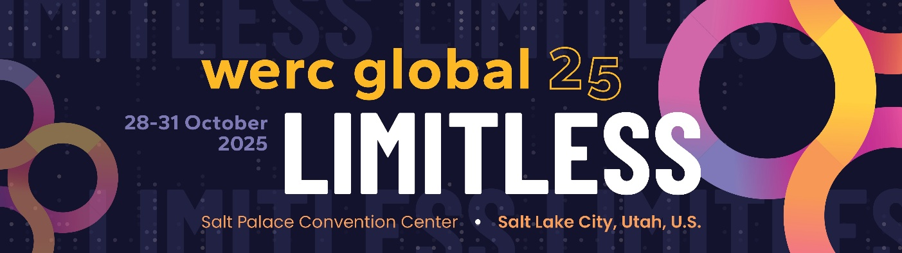

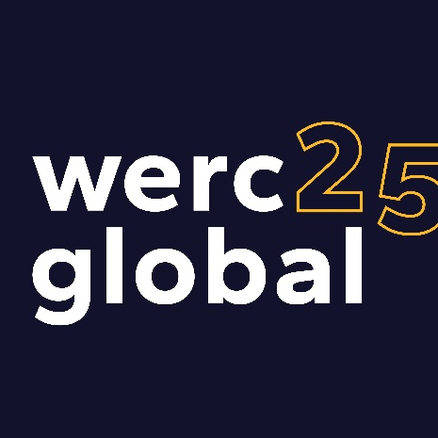

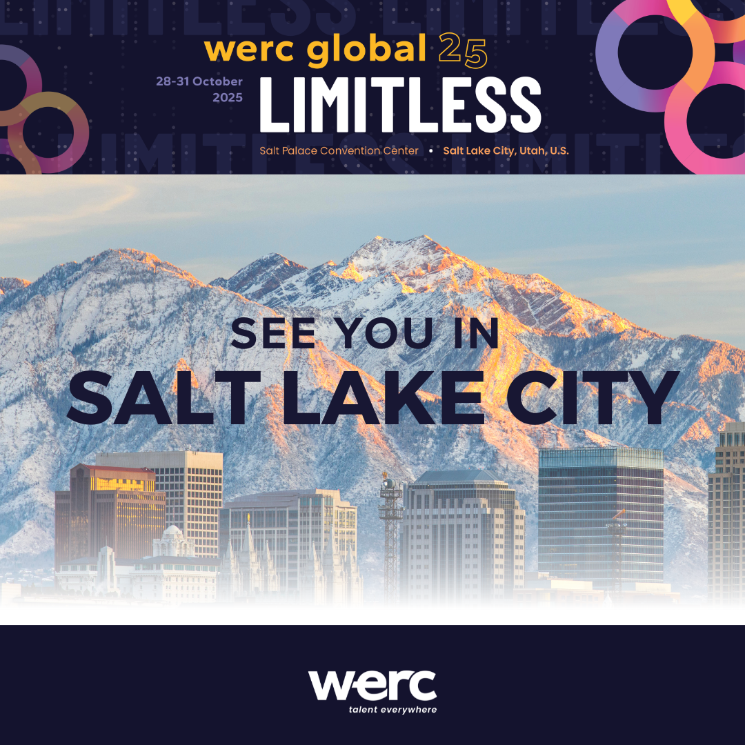

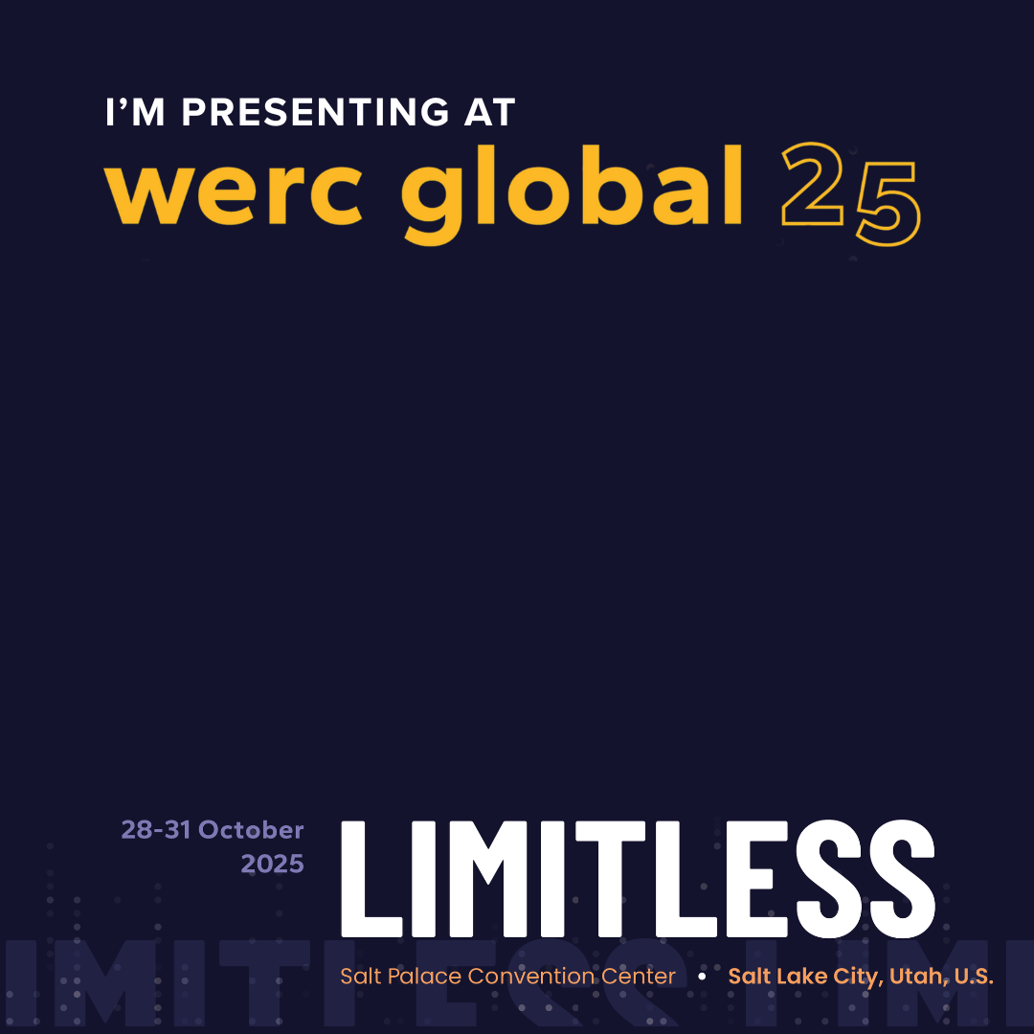

## Social Media Video Submission Request

Share a short (≤2 min) video highlighting your session.

**Video Tips:**

* Start with your name, title, and company.
* Mention your session title and 1–2 takeaways.
* Keep it conversational: “Join me at WERC Global 25 as I share **[topic]**! I’ll be diving into **[what attendees will learn or why they should attend]**.”
* Vertical format, stable camera, good lighting/audio.

**How to Submit:**  
Send via [**WeTransfer**](https://wetransfer.com/) to [marketing@talenteverywhere.org](mailto:marketing@talenteverywhere.org).   
File name format: *SpeakerName_SessionTopic_CompanyName.mp4*

Alternatively, you can record and post the video to your own social media and tag WERC so that we can repost it. Email us at [marketing@talenteverywhere.org](mailto:marketing@talenteverywhere.org) to let us know you’ve posted a video.