**WERC Global 25 Sponsor & Exhibitor Marketing Toolkit**

As a sponsor and exhibitor at WERC Global 25, you’re not just showing up — you’re helping shape the future of talent mobility. Your presence drives innovation, fosters meaningful connections, and brings critical solutions to the forefront of the global mobility community.

This toolkit is designed to help you amplify your impact, promote your participation, and boost engagement before, during, and after the event. Inside, you’ll find key messages, social media templates, graphics, a promotional email, QR code, and video submission guidelines.

Let’s make your sponsorship one to remember.

## Event Overview

* WERC Global 25 takes place **28–31 October 2025** at the **Salt Palace Convention Center** in **Salt Lake City, Utah**.
* As the premier global event for talent mobility professionals, WERC Global 25 brings together corporate, government, and service provider leaders for four days of actionable education, future-focused conversations, and powerful connections.

## Sample Social Media Posts

Promote WERC Global 25 by posting on your social media channels. Feel free to customize the posts and use your “voice.” Consider having fun with your social posts by including emojis and hashtags!

Don’t forget to follow WERC on social media and tag us.

* [Facebook](https://www.facebook.com/WorldwideERC)
* [LinkedIn](https://www.linkedin.com/company/66468?trk=tyah&trkInfo=clickedVertical%3Acompany%2CclickedEntityId%3A66468%2Cidx%3A3-1-6%2CtarId%3A1458075737848%2Ctas%3Aworldwide%20ERC)
* [Instagram](https://www.instagram.com/worldwideerc/)

**Social media tips:**

* Posts on your social media channels should generally be kept as short as possible and include hyperlinks and hashtags.
* Consider posting at high-trafficked times during the week to maximize your exposure. The optimal time to post is between 13:00 and 15:00 in your primary audience’s time zone, Monday through Thursday.

Below, we have provided some template examples, but you can and should make it your own. Tell the audience what they’ll learn or why you’re excited to be at WERC Global specifically.

**Standard**

1. We’re proud to sponsor #WERCGlobal25! Join us 28–31 October in Salt Lake City to connect, collaborate, and explore the future of talent mobility. Register now: [www.talenteverywhere.org/Global25](http://www.talenteverywhere.org/Global25)
2. We’re heading to Salt Lake City for #WERCGlobal25! Stop by our booth and connect with mobility leaders from around the world. See you there: [www.talenteverywhere.org/Global25](http://www.talenteverywhere.org/Global25)
3. WERC Global 25 is where talent mobility meets innovation, and we’re proud to be part of it as a sponsor. Don’t miss this premier event: [www.talenteverywhere.org/Global25](http://www.talenteverywhere.org/Global25)

## Email Template

**Subject:** Join **[Company Name]** at WERC Global 25

Hi **[Name]**,

We’re proud to sponsor WERC Global 25, taking place 28–31 October 2025 at the Salt Palace Convention Center in Salt Lake City, Utah, and we’d love for you to be part of it.

As an exhibitor, we’re excited to connect with mobility professionals from around the globe and showcase solutions that help organizations thrive in today’s evolving landscape. Stop by our booth to explore **[your product/service or key offering]**, meet our team, and discover new opportunities for collaboration.

**Why attend?**

* Hear from global thought leaders on immigration, AI, remote work, sustainability, tax, and more.
* Network with peers and partners across sectors and regions.
* Discover tools and ideas to drive real growth in your role and organization.

👉 [**Register now**](https://www.talenteverywhere.org/Events/WERC-Global/Registration) to be part of the conversation. We look forward to seeing you there!

Best,  
Your Name]

[Your Title/Organization]

[Contact Information]

](https://www.talenteverywhere.org/Events/WERC-Global/Registration)

**Note:** Make sure to hyperlink this graphic with the registration link: [www.talenteverywhere.org/Global25](http://www.talenteverywhere.org/Global25).

## Boilerplate

**28–31 October 2025 | Salt Palace Convention Center | Salt Lake City, Utah**

[WERC Global 25](https://www.talenteverywhere.org/Events/WERC-Global) is the premier event for the talent mobility industry, uniting professionals from across the globe to share strategies, form connections, and spark innovation. This year marks WERC’s 60th anniversary, and our program reflects that milestone with elevated content, immersive experiences, and global reach.

Expect cutting-edge sessions, interactive sessions, a sold-out expo hall, and inspiring moments like the opening keynote from Paralympian and changemaker **Amy Purdy**. Whether you're a corporate mobility leader or a service provider, this is your space to learn, grow, and lead.

**Register:** [www.talenteverywhere.org/Global25](http://www.talenteverywhere.org/Global25)

## QR Code

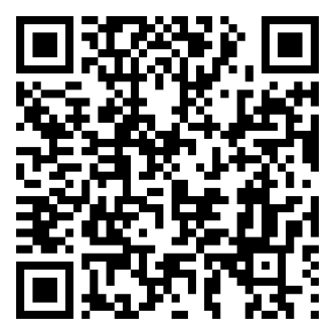To make it easy for your network to register, include the following QR code in your communications:

*Scan to Register*

## Social Media Graphics

Add these to your website, social media posts, and corporate communications promoting the event. To download the graphics, hover on the select graphic, **right-click** and select **“save as picture**.”



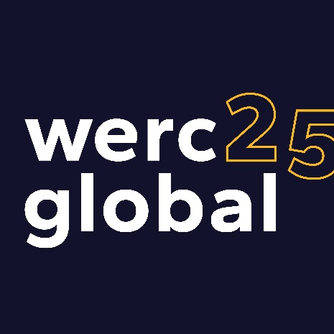



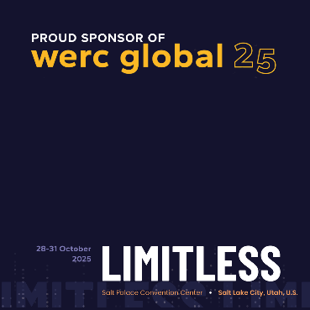

## Social Media Video Submission Request

Share a short (≤2 min) video highlighting your session.

**Video Tips:**

* Start with your name, title, and company.
* Mention your session title and 1–2 takeaways.
* Keep it conversational: “Join me at WERC Global 25 as I share **[topic]**! I’ll be diving into **[what attendees will learn or why they should attend]**.”
* Vertical format, stable camera, good lighting/audio.

**How to Submit:**  
Send via [**WeTransfer**](https://wetransfer.com/) to [marketing@talenteverywhere.org](mailto:marketing@talenteverywhere.org).   
File name format: *SpeakerName_SessionTopic_CompanyName.mp4*

Alternatively, you can record and post the video to your own social media and tag WERC so that we can repost it. Email us at [marketing@talenteverywhere.org](mailto:marketing@talenteverywhere.org) to let us know you’ve posted a video.