
WERC Global 25 Volunteer Marketing Toolkit
As a WERC volunteer leader, your voice and presence are instrumental in shaping the future of talent mobility.
Your commitment drives progress, inspires innovation, and helps foster the connections that power our global community. Your leadership doesn't just guide the conversation, it elevates it.
This toolkit is designed to help you amplify your role, promote the event, and engage your network before, during, and after WERC Global 25. Inside, you’ll find key messages, social media templates, graphics, a promotional email, QR code, and video submission guidelines.
Let’s work together to make this year’s event the most impactful yet.
Event Overview
- WERC Global 25 takes place 28–31 October 2025 at the Salt Palace Convention Center in Salt Lake City, Utah.
- As the premier global event for talent mobility professionals, WERC Global 25 brings together corporate, government, and service provider leaders for four days of actionable education, future-focused conversations, and powerful connections.
Sample Social Media Posts
Promote WERC Global 25 by posting on your social media channels. Feel free to customize the posts and use your “voice.” Consider having fun with your social posts by including emojis and hashtags!
Don’t forget to follow WERC on social media and tag us.
- Facebook
- LinkedIn
- Instagram

Social Media Tips:
- Write a short caption that feels like you—while encouraging others to attend WERC Global 25 and showing enthusiasm for the event.
- Posts on your social media channels should generally be kept as short as possible and include hyperlinks and hashtags.
- Consider posting at high-trafficked times during the week to maximize your exposure. The optimal time to post is between 13:00 and 15:00 in your primary audience’s time zone, Monday through Thursday.
Below, we have provided some guidelines and prompts for writing social media posts promoting WERC Global 25. Tell the audience what they’ll learn or why you’re excited to be at WERC Global specifically.
Key Elements to Include
Aim to touch on 2–3 of the following in your post:
- ✔️ You’re attending WERC Global 25
- ✔️ What you’re most excited about (sessions, networking, innovation, etc.)
- ✔️ A personal reason why this event matters to you
- ✔️ An invite to others to join or connect
- ✔️ Event info or registration link: www.talenteverywhere.org/Global25
- ✔️ Hashtag: #WERCGlobal25

Prompt Yourself with These Questions
Use these as a jumping-off point to create your post:
- What excites you most about attending WERC Global 25?
- Why do you think others should attend?
- What kind of impact do you hope this event will have on the mobility community?
- How are you involved—as a board member, volunteer, etc.?
- Are you looking forward to reconnecting with anyone?
- Is there a specific topic or trend you’re eager to explore?
Tone Tips
Keep your post:
- Positive – Focus on what you're looking forward to
- Genuine – Write like you speak
- Professional – Avoid slang or overly casual language
- Concise – Aim for 1–3 short sentences
Plug-and-Play Starters
Here are a few sentence starters you can personalize:
- “I’m thrilled to be heading to Salt Lake City this October for #WERCGlobal25...”
- “WERC Global 25 is always a highlight of my year and I’m proud to be part of it again in 2025.”
- “If you’re passionate about the future of talent mobility, this is the event to attend.”
- “So much energy, insight, and innovation in one place—I can’t wait for you to experience it.”
Email Template
Subject: Join Me at WERC Global 25
Hi [Name],
I’m excited to share that I’ll be attending WERC Global 25, happening 28–31 October 2025 at the Salt Palace Convention Center in Salt Lake City, Utah, and I hope you’ll join me there!
As a WERC [volunteer position], I’ve had a front-row seat in shaping this year’s event, and I can confidently say there’s something truly special in store. From bold conversations to fresh insights and powerful networking, WERC Global 25 is where the global mobility community comes together to collaborate, learn, and lead.
Why attend?
• Hear from global thought leaders on topics like immigration, AI, sustainability, tax, and remote work
• Make meaningful connections with peers and partners across industries and regions
• Discover strategies, tools, and ideas you can bring back to your team
👉 Register now to be part of the conversation. I’d love to see you there!
Best,
[Your Name]
[Your Title/Organization]
[Contact Information]


Note: Make sure to hyperlink this graphic with the registration link: www.talenteverywhere.org/Global25.
Boilerplate
28–31 October 2025 | Salt Palace Convention Center | Salt Lake City, Utah
WERC Global 25 is the premier event for the talent mobility industry, uniting professionals from across the globe to share strategies, form connections, and spark innovation. This year marks WERC’s 60th anniversary, and our program reflects that milestone with elevated content, immersive experiences, and global reach.
Expect cutting-edge sessions, interactive sessions, a sold-out expo hall, and inspiring moments like the opening keynote from Paralympian and changemaker Amy Purdy. Whether you're a corporate mobility leader or a service provider, this is your space to learn, grow, and lead.
Register: www.talenteverywhere.org/Global25

QR Code
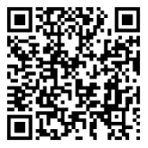
To make it easy for your network to register, include the following QR code in your communications:
Scan to Register
Social Media Graphics
Add these to your website, social media posts, and corporate communications promoting the event. To download the graphics, hover on the select graphic, right-click and select “save as picture.”

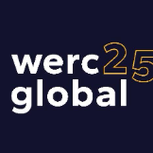
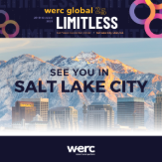
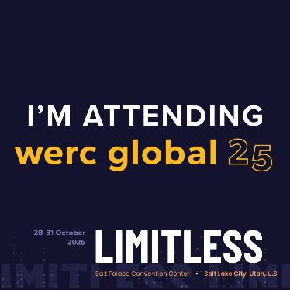
Social Media Video Submission Request
Share a short (≤2 min) video highlighting your session.
Video Tips:
- Start with your name, title, and company.
- Mention your session title and 1–2 takeaways.
- Keep it conversational: “Join me at WERC Global 25 as I share [topic]! I’ll be diving into [what attendees will learn or why they should attend].”
- Vertical format, stable camera, good lighting/audio.
How to Submit:
Send via WeTransfer to marketing@talenteverywhere.org.
File name format: SpeakerName_SessionTopic_CompanyName.mp4
Alternatively, you can record and post the video to your own social media and tag WERC so that we can repost it. Email us at marketing@talenteverywhere.org to let us know you’ve posted a video.

